The name of your system

XXXX-MM-DD

Leader: student name (student id) Module: module name

Members: student name (student id) Module: module name

student name (student id) Module: module name

student name (student id) Module: module name

**1.Objectives**

**Could copy from the document of the term projects.**

**2. Overall architecture — 20 points**

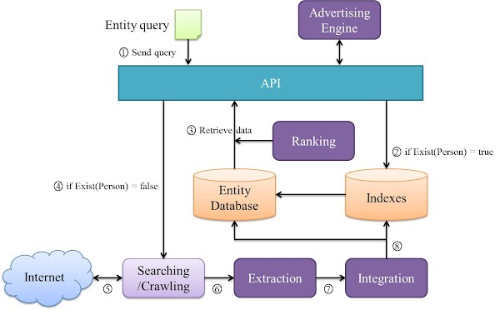

Figure 1 Overall architecture of xxxx

After showing the figure, you should explain the components and their relationships of your system

**3. System Design**

**3.1. System Flow — 10 points**

**Place a figure of system flow here.**

**You can copy from the documents, but you should modify it according to your actual work.**

**3.2 System functions — 30 points**

**Place a figure of division of system functions here.**

**You can copy from the documents, but you should modify it according to your actual work.**

(1) function 1

Explain each function, design the process figure to describe the business logic of realizing the function, and use suitable sentences to describe the process figure.

(2) function 2

(3) …….

**3.3 Database Design -- 20 points**

Use a E-R figure to describe how many tables are there in your system according to the system function, and also list the relationship between any two tables.

Use table to list all the structures of each table according to the E-Rt figure.

Table 1. XXXX

|  |  |  |  |  |
| --- | --- | --- | --- | --- |
| Field | Data Type | Main Key | Foreign Key | Desc |

**4. System Testing—20 points**

Using a series of screenshots of your system to show the main functions of your system. Excepts the figures, you should use several logical sentences to connect all the figures.

Everybody should annotate your name at the paragraph where you write.